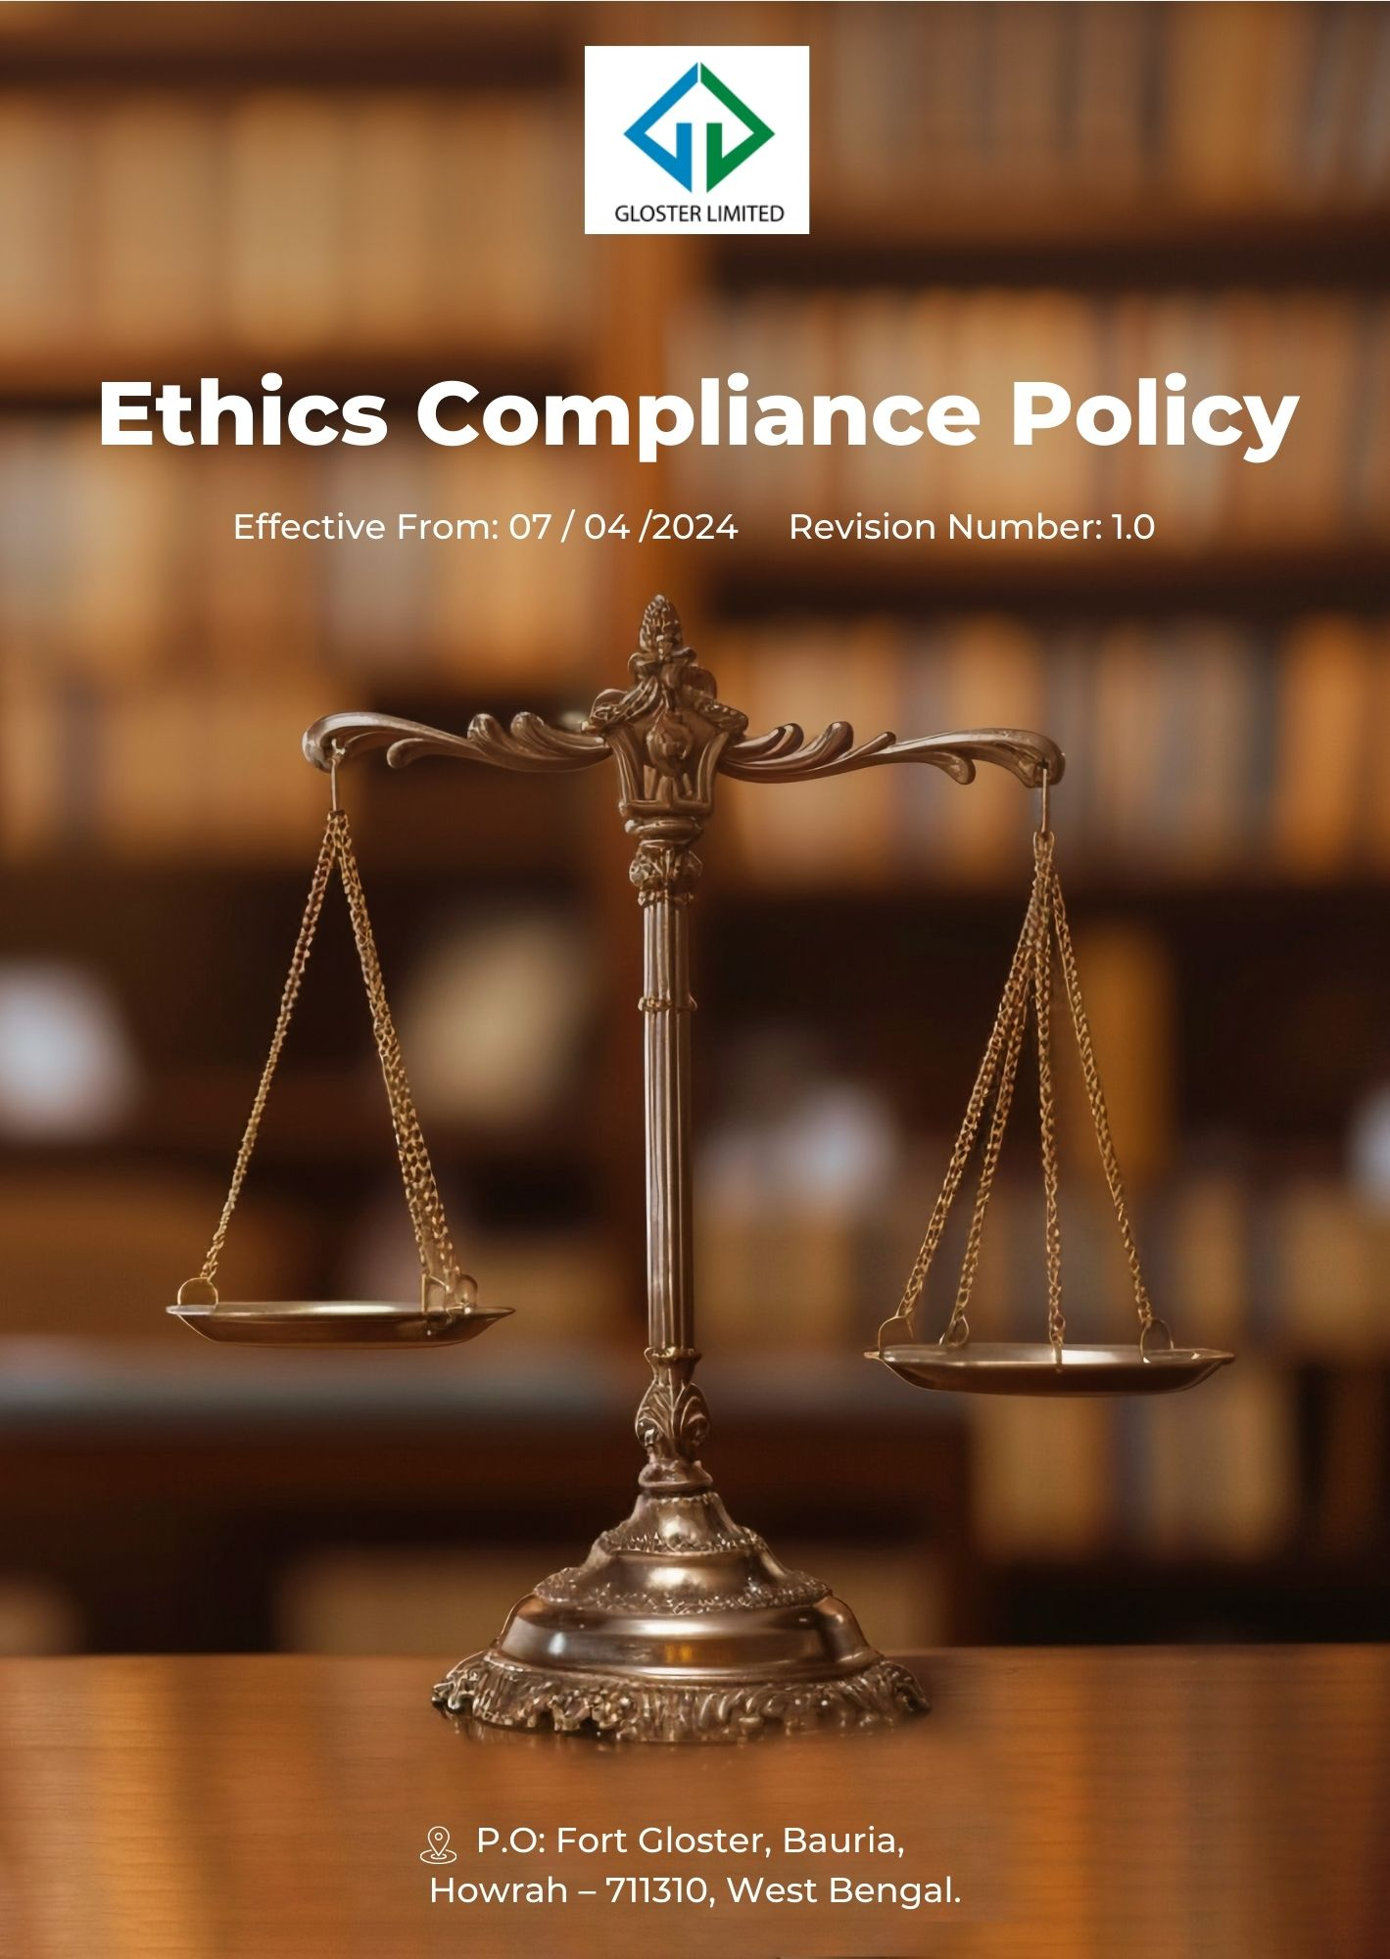
Contents
1) Preamble 3
2) Desired Outcomes 3
3) Scope 3
4) Core Ethical Strategies 4
5) Guidelines for Employees 6
6) Ethics and Compliance Assessment 9
7) Accountability 9
8) Training and Education 10
9) Reporting and Investigation Procedures 10
10) Progress Update 11
11) Consequences for Violation of this Policy 12
12) Ongoing Development 13
13) Review Cycle 14
14) Employee Acknowledgement Form 15

Preamble
At Gloster Limited, we are dedicated to upholding the highest levels of ethics and compliance within our jute manufacturing operations. Our Ethics & Compliance Policy is crafted to ensure integrity, transparency, and accountability throughout every aspect of our business. We aim to cultivate a work environment that promotes ethical conduct and adherence to all applicable laws and regulations. This policy highlights our commitment to ethical practices and the strategies we have put in place to meet these standards.
We continually assess and refine our policies to address emerging challenges and ensure that our practices remain aligned with the latest industry standards and best practices. Our goal is to build trust with our stakeholders and reinforce our reputation as a responsible and ethical organization.

Desired Outcomes
By implementing this policy, Gloster Limited aims to achieve the following outcomes:
- To promote a culture of ethical behavior and integrity within our organization, ensuring that all employees and stakeholders adhere to our high standards of conduct.
- To comply with all applicable laws and regulations governing our industry and operations, including anti-bribery, anti-money laundering, and data protection.
- To prevent and address any instances of misconduct, fraud, or unethical behavior, ensuring a safe and transparent workplace for all employees.
- To continuously review and improve our ethical practices and compliance mechanisms, adapting to changes in laws, regulations, and industry standards.

Scope
This Policy applies to all employees (at all levels), stakeholders (internal and external), partners, contractors, customers, suppliers, and any other individual or entity working on behalf of Gloster Limited. It also applies to the following sites.
Sr.No. | Unit Name | Address
1 | GLOSTER LIMITED-Ananya Unit | P.O: Fort Gloster, Bauria, Howrah – 711310, West Bengal
2 | GLOSTER LIMITED-Head Office | Head Office, 21, Strand Road, Kolkata 700001

Core Ethical Strategies
Our commitment to ethical practices underscores the strategies and actions we implement to advance social justice and uphold high standards across our operations. These initiatives reflect our dedication to responsible business conduct and ongoing enhancement in our industry.
- Anti-bribery and Corruption Prevention Measures
- We aim to implement a comprehensive anti-corruption program with regular training and audits, ensuring the continuation of our 20-year record of zero bribery incidents, with the goal of maintaining this status through at least 2029-30.
- Our to transparency includes aiming for full disclosure of transactions above a certain commitment threshold by FY 2029-30, in comparison to FY 2022-23.
- We are in progress of implementing rigorous due diligence to all third-party relationships, we target a 50% completion rate for risk assessments by FY 2029-30, based on FY 2023-24 data.
- Ethical Conflict Resolution and Mediation
- We aim to establish an independent ethics committee to address conflicts, with a goal to resolve 95% of reported issues within 20 days by FY 2029-30, compared to FY 2022-23
- We aim to enhance our confidential whistle blowing system to reported ethical concerns striving to the continuation of our 20-year record of zero cases of conflict-of-interest incidents, with the goal of maintaining this status through at least 2029-30.
- We are in progress to train all employees to raise awareness about conflicts of interest and reduce incidents of ethical misconduct by 75% by FY 2029-30, using FY 2022-23 as the baseline.
- Financial Integrity and Anti-fraud Control Systems
- We aim to implement automated fraud detection software to monitor transactions and ensuring the continuation of our 20-year record of zero Fraud incidents, with the goal of maintaining this status through at least 2029-30.
- We aim to conduct regular financial audits and fraud prevention training are set to ensuring the continuation of our 20-year record of zero fraud incidents, with the goal of maintaining this status through at least 2029-30.
- We are in progress to implement robust internal control system will ensure 100% compliance with financial frameworks by FY 2029-30, in comparison to the baseline year FY 2022-23.
- Comprehensive Economic Crime Prevention Strategies
- We aim to implement advanced monitoring systems for all financial transactions, with a target to achieve 100% real-time screening for high-risk transactions and money laundering by FY 2029-30, based on FY 2022-23
- We aim to conduct regular risk assessments across all business units aim to identify and mitigate economic crime and money laundering risks, targeting a 95% risk mitigation rate by FY 2029-30, relative to FY 2022-23.
- We aim to implement a comprehensive anti-money laundering program with regular training and audits, ensuring the continuation of our 20-year record of zero cases of money laundering incidents, with the goal of maintaining this status through at least 2029-30.
- Promoting Fair Competition and Antitrust Compliance
- We aim to comprehensive antitrust compliance program will train 50% all relevant employees by FY 2029-30, aiming for full training coverage from the baseline year FY 2022-23.
- We strive to conduct regular antitrust risk assessments are set to reduce potential violations by 50% by FY 2029-30, compared to FY 2023-24 levels.
- We aim to implement a comprehensive anti-trust program with regular training and audits, ensuring the continuation of our 20-year record of zero cases of fair-competition incidents, with the goal of maintaining this status through at least 2029-30.
- Collaborative efforts with industry peers aim to establish common antitrust guidelines by FY 2029-30, promoting fair competition across the industry.
- Prevention of Data Manipulation and Integrity Maintenance
- We are in process to implement advanced data validation systems will reduce incidents of data manipulation by 95% by FY 2029-30, compared to the baseline year FY 2022-23.
- A multi-level approval process for data changes is aimed at achieving 100% adherence by FY 2029-30, in comparison to FY 2022-23.
- We are in process to implement blockchain technology for critical data storage to ensure 100% immutability and traceability of sensitive data by FY 2029-30, from the baseline year FY 2022-23.
- We aim to maintain zero information security breach cases, continuing our record of secure data management through at least FY 2029–30.
- Intellectual Property Theft Prevention and Protection
- We are in process to stringent access controls and monitoring systems to reduce the risk of intellectual property theft by 90% by FY 2029-30, compared to FY 2022-23.
- We aim to conduct regular IP audits and training for employees will target 100% awareness of IP protection by FY 2029-30, relative to the baseline year FY 2022-23.
- Comprehensive Data Protection and Cybersecurity Measures
- We are in process to implement advanced encryption and security protocols to prevent 99% of unauthorized data access attempts by FY 2029-30, compared to FY 2023-24 levels.
- We aim to implement a comprehensive information security program with regular training and audits, ensuring the continuation of our 20-year record of zero cases of information security breach, with the goal of maintaining this status through at least 2029-30.
- Regular cybersecurity drills and training aim to cut successful phishing attempts by 75% by FY 2029-30, from the baseline year FY 2022-23.
- We aim to implement a zero-trust security model to enhance cybersecurity, targeting 100% implementation across all systems by FY 2029-30, based on FY 2022-23.
We aim to train 100% of our employees on all ethical issues, including but not limited to corruption, anti-competitive practices, fraud, money laundering, antitrust, and information security, by FY 2029-30, using FY 2022-23 as the baseline.

Guidelines for Employees
- Confidentiality and Data Protection
- Employees shall safeguard confidential business, customer, supplier, and employee information at all times.
- Confidential information must be accessed, used, stored, and shared strictly on a need-to-know basis and with proper authorization.
- Employees shall comply with applicable data protection laws, IT security policies, and cybersecurity controls.
- Any actual or suspected data breach, loss, or unauthorized access must be reported immediately.
Example:
- Keep contracts, employee records, and designs safe and only let authorized people see them.
- Don’t share internal data or reports with outside parties unless you get permission first.
- Integrity and Ethical Conduct
- Employees shall act with honesty, fairness, and integrity in all professional interactions.
- Misrepresentation, falsification of records, or unethical behavior is strictly prohibited.
- All business communications and records must be accurate and complete.
- Suspected unethical conduct must be reported without fear of retaliation.
Example:
- Always report accurate production, sales, or compliance data.
- Don’t change records to hide mistakes or problems.
- Prevention of Money Laundering and Financial Crime
- Employees shall not engage in or facilitate money laundering, fraud, or any financial crime.
- All financial transactions must be conducted transparently through authorized company systems.
- Employees shall follow customer, vendor, and transaction due diligence requirements.
- Any suspicious or unusual financial activity must be promptly reported to the Compliance Officer.
Example:
- Verifying customer and supplier credentials before processing payments.
- Don’t process unusual payments without proper documents or approval.
- Anti-Bribery and Corruption
- Employees shall not offer, solicit, or accept bribes, kickbacks, or improper advantages.
- Gifts, hospitality, and entertainment must comply with company limits and approval procedures.
- Interactions with government officials shall strictly follow applicable laws.
- Any suspected corrupt practice must be reported immediately.
Example:
- Say no to gifts or favors that could influence business decisions.
- Say no to gifts or favors that could influence business decisions.
- Conflict of Interest
- Employees shall avoid situations where personal interests conflict with company interests.
- Any actual or potential conflict of interest must be disclosed in a timely manner.
- Employees shall not use their position for personal benefit.
- Decision-making must remain objective and transparent.
Example:
- Tell your manager if you have personal connections with a supplier before approving a deal.
- Don’t use your position to benefit yourself or family members.
- Respectful Workplace Conduct
- Employees shall treat colleagues, contractors, and stakeholders with dignity and respect.
- Discrimination, harassment, intimidation, or abusive behavior is strictly prohibited.
- A safe, inclusive, and professional workplace environment shall be maintained.
- Inappropriate conduct must be reported promptly.
Example:
- Treat everyone with respect and avoid offensive language.
- Don’t harass, intimidate, or discriminate against colleagues.
- Use of Company Assets and Resources
- Company assets shall be used responsibly and solely for legitimate business purposes.
- Employees shall protect company property from misuse, damage, or theft.
- Unauthorized personal use of company resources is prohibited.
- Any misuse or loss of assets must be reported.
Example:
- Use company equipment only for work tasks.
- Don’t use company vehicles, tools, or materials for personal reasons.
- Compliance with Laws, Policies, and Standards
- Employees shall comply with all applicable laws, regulations, and internal policies.
- Employees are expected to be aware of and follow policies relevant to their roles.
- Cooperation with audits, inspections, and investigations is mandatory.
- Any violation of laws or company policies must be reported.
Example:
- Follow labor, environmental, and safety rules at all times.
- Don’t ignore laws or policies just to meet deadlines.
- Health, Safety, and Environmental Responsibility
- Employees shall follow all occupational health, safety, and environmental procedures.
- Safety equipment and environmental controls must be used correctly.
- Unsafe conditions, incidents, or environmental risks must be reported immediately.
- Employees shall support sustainable and environmentally responsible practices.
Example:
- Report safety hazards and separate waste correctly.
- Don’t skip safety steps to save time.

Ethics and Compliance Assessment
We will conduct regular and comprehensive ethics and compliance assessments to evaluate the effectiveness of our policies and procedures. These assessments will include:
- Annual ethics audits conducted by an independent third party
- Quarterly compliance risk assessments across all business units
- Annual employee surveys on ethical culture and awareness
- Monthly review of reported incidents and their resolutions
- Benchmarking against industry best practices and international standards

Accountability
To ensure the effective implementation of this policy, we have established clear roles and responsibilities:
- Board of Directors:
- The Board will also evaluate the effectiveness of the ethics program annually and provide strategic guidance on emerging ethical challenges.
- They will ensure that resources allocated to the ethics program are sufficient to meet the company's ethical and compliance goals.
- Ethics and Compliance Committee:
- The Committee will oversee the integration of ethical considerations into business practices and ensure adherence to industry regulations.
- They will also assess the effectiveness of the ethics training programs and recommend improvements as necessary.

- Chief Compliance Officer
- Oversee the implementation the Ethics and Compliance Policy.
- The Chief Ethics and Compliance Officer will regularly review compliance metrics and report trends to the Ethics and Compliance Committee.
- They will work closely with other departments to ensure alignment with ethical standards and to address any compliance gaps.
- Department Heads:
- Department Heads will ensure that ethical behavior is a key component of performance evaluations and reward systems.
- They will actively participate in the development and communication of ethics-related goals and initiatives within their teams.
- Employees:
- Employees are encouraged to seek guidance on ethical dilemmas and to use the resources provided to make informed decisions.
- They are expected to actively participate in ethics training and to contribute to a supportive environment for reporting concerns.

Training and Education
We will provide comprehensive and ongoing ethics and compliance training to all employees, including:
- Annual ethics refresher courses for all employees
- Role-specific compliance training for employees in high-risk positions
- New hire ethics orientation within the first month of employment
- Quarterly leadership ethics workshops for managers and executives
- Monthly ethics newsletter and case study discussions
- Online ethics resource center with guidelines, FAQs, and decision-making tools

Reporting and Investigation Procedures
We maintain a robust system for reporting and investigating ethical concerns:
- Multiple reporting channels including an anonymous hotline, web portal, and in-person reporting
- Clear and well-communicated procedures for submitting reports
- Trained investigators to handle all reports promptly and thoroughly
- Regular updates to reporters on the status of investigations
- A non-retaliation policy to protect those who report concerns in good faith

Progress Update
To ensure transparency and continuous improvement, we will implement the following reporting mechanisms:
- Reporting Frequency and Mechanism
- Monthly Reports: Each department will submit a monthly ethics and compliance performance report to the Chief Ethics and Compliance Officer. These reports will include data on training completion rates, reported incidents, resolved cases, and progress toward specific ethical targets.
- Quarterly Reviews: The Ethics and Compliance Committee will compile and analyze monthly reports to produce a quarterly ethics and compliance performance review. This review will be presented to the Board of Directors and made available to all employees.
- Annual Ethics Report: An annual comprehensive ethics and compliance report will be prepared, summarizing the yearly performance, progress toward goals, significant incidents and their resolutions, and outlining plans for the following year. This report will be shared with all stakeholders and made publicly available on the company's website.
- Internal Communication and Feedback
- Regular Meetings: The Chief Ethics and Compliance Officer will hold monthly meetings with department heads to discuss ethics performance, challenges, and opportunities for improvement. These meetings will ensure that ethical initiatives are aligned with operational goals and that any issues are promptly addressed.
- Employee Engagement: Bi-weekly updates on ethics and compliance matters will be provided to all employees through internal newsletters, emails, and the company intranet. An anonymous feedback mechanism will be maintained to encourage employees to share their thoughts on the company's ethical culture and suggest improvements.
- Stakeholder Engagement
- Transparency: We will maintain transparent communication with our stakeholders, including customers, suppliers, and local communities. Quarterly updates on our ethics and compliance performance and initiatives will be shared through various channels, such as newsletters, social media, and our website.
- Stakeholder Meetings: Semi-annual stakeholder meetings will be held to discuss our ethics and compliance policy, share progress, and gather feedback. These meetings will provide a platform for open dialogue and collaborative problem-solving on ethical issues.

Consequences for Violation of this Policy
- Disciplinary Action
- Verbal Warning: For minor infractions or first-time violations, a verbal warning will be issued, emphasizing the importance of adherence to the policy.
- Written Warning: Continued violations or more serious breaches will result in a written warning that documents the nature of the violation and the required corrective actions.
- Suspension: Repeated violations or severe breaches may lead to temporary suspension from duties, with or without pay, depending on the severity of the breach.
- Termination of Employment
- Immediate Termination: In cases of serious violations such as fraud, corruption, or gross misconduct, immediate termination of employment may occur. This decision will be based on a thorough investigation and will follow all legal and contractual obligations.
- Legal Action
- Civil and Criminal Proceedings: For violations that involve illegal activities such as bribery, money laundering, or intellectual property theft, legal action will be pursued. This may involve reporting the incident to law enforcement authorities and cooperating with legal proceedings.
- Financial Penalties
- Fines and Restitution: In cases where financial damage has occurred, the company may seek restitution or impose fines on the responsible individuals or entities.
- Reputational Consequences
- Public Disclosure: Serious breaches that affect the company’s reputation may result in public disclosure of the violation, which could impact the individual’s professional reputation and future employment opportunities.
- Training and Re-education
- Mandatory Training: Individuals involved in policy violations may be required to undergo additional ethics and compliance training to address the issues that led to the violation and to prevent future occurrences.
- Performance Review Impact
- Negative Impact on Evaluations: Violations of the policy will negatively affect performance reviews, impacting salary adjustments, promotions, and other career advancement opportunities.
- Contractual Penalties
- Termination of Contracts: For external partners, suppliers, or contractors, breaches of the policy can lead to the termination of contracts and potential blacklisting from future engagements with the company.
- Corrective Actions
- Implementation of Corrective Measures: The company will require individuals or departments involved in the violation to implement corrective actions to rectify the issues and prevent recurrence.

Ongoing Development
At Gloster Limited, our commitment to continuous improvement is integral to maintaining high ethical standards and operational excellence. We will regularly assess and refine our ethics and compliance strategies to address emerging challenges and align with best practices. This includes incorporating feedback from stakeholders, reviewing performance metrics, and staying abreast of industry developments. Our process involves rigorous internal audits, annual ethics reviews, and regular updates to our policies based on assessment outcomes. We will also foster a culture of proactive learning through ongoing employee training and development programs. By leveraging insights from these evaluations and engaging with industry experts, we aim to enhance our ethical practices continually. Our goal is to ensure that our operations not only meet but exceed the expectations of our stakeholders and regulatory requirements.

Review Cycle
This policy shall be reviewed annually and on an ad hoc basis by the Chief Compliance Officer and the Ethics Committee to ensure its continued effectiveness and relevance. Any material changes shall be approved by the Board of Directors.
Policy | Responsible Person | Signature | Date
Prepared by | Chief Compliance Officer |  | 30th March 2023
Approved by | General Manger |  | 01st April 2023

Reviewed by | Review Date | Signature | Revised No. | Change Summary
Chief Compliance Officer | 01st April 2024 |  | 1.0 | Updated section of “Progress Update”
Chief Compliance Officer | 01st April 2025 |  | 1.1 | Updated “Review Cycle”
Next Review date: 01st April 2026

Employee Acknowledgement Form
I, acknowledge that I have received, read, and understood the Ethics & Compliance Policy of Gloster Limited. I am aware of the company's commitment to ethical conduct and the standards outlined in the policy, including anti-bribery, anti-corruption, and data protection. I understand my responsibilities to adhere to these standards and to report any concerns or violations through the established channels. I recognize that failure to comply with this policy may result in disciplinary action, including possible termination of employment.
I commit to upholding the ethical values and compliance requirements as outlined and agree to participate in required training and development programs. I understand that my role involves contributing to a culture of transparency and integrity, and I am expected to actively engage in maintaining the highest standards of ethical conduct.
Furthermore, I acknowledge that I will be provided with ongoing support and resources to help navigate any ethical issues that arise. I am encouraged to seek guidance whenever necessary and to participate in continuous improvement initiatives to ensure our organization remains a leader in ethical practices.
Employee Name: ____________________________
Employee Signature: _________________________
Date: ______________________

